An Internship REPORT


SUBMITTEDTO SAVITRIBAI PHULE PUNE UNIVERSITY, PUNE
IN PARTIAL FULFILLMENT OF THE REQUIREMENTS
FOR THE AWARD OF THE DEGREE

BACHELOR OF ENGINEERING (Computer Engineering)

BY

Shrinath Suresh Dasarwar (T1906004224 / 72205069M )

Under the guidance of


Internship Faculty Mentor: Prof. Supriya Agre

DEPARTMENT OF COMPUTER ENGINEERING
DHOLEPATILCOLLEGEOFENGINEERING
WAGHOLI, PUNE-412207.
(AY # 2024-25)

 | DHOLEPATILCOLLEGEOFENGINEERING, PUNE  DEPARTMENTOFCOMPUTERENGINEERING

CERTIFICATE

This is to certify that the Internship Completion Report “WEB DEVLOPMENT” Being submitted by Dasarwar Shrinath Suresh is a Bonafide work carried out by her under the Supervision and guidance of Prof. Supriya Agre in partial fulfilment of the requirement for the TE Computer Engineering course of Savitribai Phule Pune University, Pune in the Academic year 2024 - 2025.

Prof. Supriya Agre Dr. Aarti Dandavate
Internship Coordinator Head of Department
Department of Computer Engineering, Department of Computer Engineering, DPCOE, Pune DPCOE, Pune

Internship Mentor Name and Sign:

Internal Examiners name and sign:
1
2
3

Date:
Place: DPCOE, Pune

ACKNOWLEDGEMENT

This is a great pleasure & immense satisfaction to express my deepest sense of gratitude & thanks to everyone who has directly or indirectly helped me in completing my internship work successfully.

I express my gratitude to Internship Coordinator Prof.Supriya Agre and Dr. Aarti Dandavate, Head of the Department of Computer Engineering, Dhole Patil College of Engineering, Pune who guided & encouraged me in completing the internship work within the scheduled time.

I would like to thank our Principal Dr. Abhijit Dandavate, for allowing us to pursue my
Internship at this institute.

Last but not least I would also like to thank DCDIUM and its core members i.e.

Founder & CEO – Deepak Chapade – my supervisor for always guiding me through the term of my internship.

Dasarwar Shrinath Suresh
T1906004224
DPCOE, Pune

Internship Completion Certificate

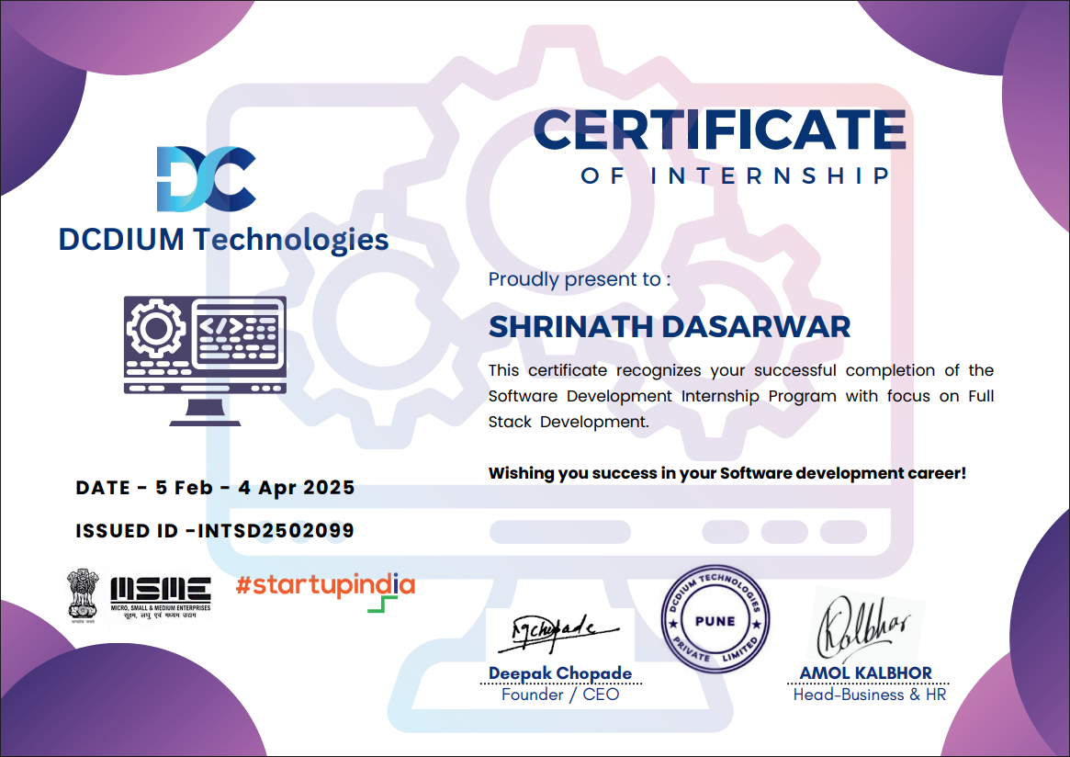

Internship Appointment letter

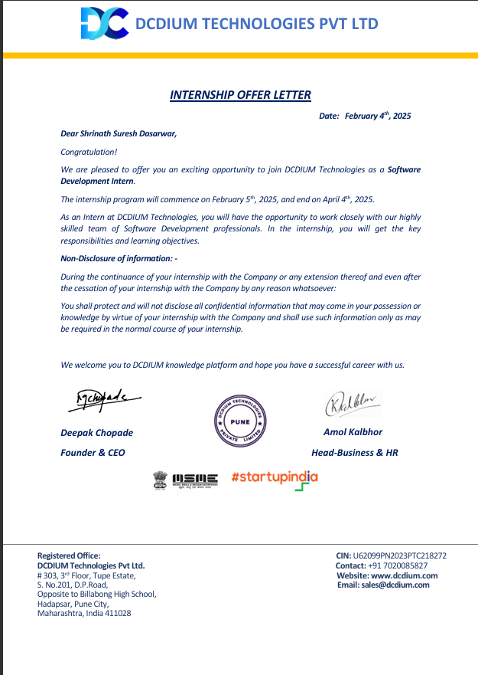

Index

Sr no | Content | PageNo
1 | Introduction
2 | Problem statement
3 | Objectives
4 | Motivation
5 | Project Modules
6 | Result Analysis and Screenshots
7 | Suggestions and Recommendations
8 | Conclusion

- Introduction

In today’s digital age, the internet has become a fundamental part of daily life, and web development plays a vital role in connecting people with information, services, and products. Web development refers to the process of building, creating, and maintaining websites and web applications. It includes everything from simple static pages to complex dynamic platforms that handle real-time data and user interactions. With businesses, educational institutions, and individuals increasingly relying on online platforms, there is a growing demand for websites that are not only visually appealing but also functional, responsive, and user-friendly.

This project focuses on designing and developing a fully functional and responsive web application using modern web technologies such as HTML, CSS, and JavaScript. These tools form the foundation of the front-end development process. In some cases, the project may also involve backend integration using Node.js, which enable server-side processing, data management, and user authentication.

The purpose of this project is to create a web-based system that addresses a specific real-world need—such as a shopping website, help desk management system, or service booking platform—while adhering to best practices in UI/UX design, code optimization, and responsive layout design. The application is structured to include essential features such as navigation menus, interactive components, form validation, dynamic content loading, data persistence using local Storage or backend storage, and responsive design elements that adapt to various devices and screen sizes.

As part of this project, careful attention is paid to the user experience. Every element, from layout to interactivity, is designed to be intuitive and efficient. The interface aims to reduce complexity while increasing functionality, allowing users to complete their tasks with minimal effort. Furthermore, the project serves as a learning experience in applying theoretical knowledge of web development to a practical, real-world scenario.

In summary, this project not only demonstrates technical proficiency in web technologies but also emphasizes problem-solving, creativity, and the ability to build solutions that are accessible and scalable. Whether for commercial use or educational demonstration, the developed web application is a step toward mastering modern web development practices and understanding the impact of digital transformation in everyday life.

- Problem Statement

In the current digital environment, users demand intuitive and fast web interfaces. However, many websites and applications face several issues:

- Poor UI/UX design.

- Slow loading times and lack of responsiveness.

- No interactive features like live cart updates, instant feedback, or real-time data manipulation.
- Lack of proper structure and maintainability.

- To address these concerns, we propose to develop a feature-rich and user-friendly web application that solves real-world problems while implementing best practices in web development.

3. Objectives

The primary objective of this web development project is to design and implement a dynamic, responsive, and user-friendly web application that effectively addresses a specific real-world need, such as an online shopping system, help desk management platform, or service booking site. The application aims to provide users with an intuitive interface, smooth navigation, and interactive features that enhance their overall experience. Through the use of modern web technologies like HTML, CSS, JavaScript, and optionally backend frameworks such as Flask or Node.js, the project seeks to deliver a fully functional and aesthetically pleasing website.

One of the key goals is to ensure the application is responsive—that is, it should adapt seamlessly to different devices and screen sizes, including desktops, tablets, and smartphones. This is crucial in today’s mobile-first world, where users expect websites to perform well across platforms. The project also aims to implement interactive features using JavaScript, such as real-time cart updates, form validation, dynamic content rendering, and data handling through localStorage or API calls.

Another major objective is to maintain modularity and clean code structure. This involves writing well-organized, readable, and reusable code to ensure long-term maintainability and scalability of the application. By following best practices in web development, such as separating content (HTML), presentation (CSS), and behavior (JavaScript), the project emphasizes the importance of clean design architecture.

The application will also focus on providing user-oriented functionality, such as:
- A homepage with navigation and an introduction to the site.
- A product or service listing page with filtering/search options.
- A shopping cart or request management system with item manipulation features.
- A checkout or query submission form with proper input validation and user feedback.
In addition, the project may include an admin module (optional) for managing data such as adding, editing, or deleting product entries or responding to user queries. This enables easier content and service management, especially for commercial use.

Overall, this project aims to demonstrate how front-end and optional back-end technologies can be integrated to build a real-world application. It serves as both a practical learning experience and a working solution for everyday tasks in e-commerce, customer service, or business management.

4. Motivation

In recent years, the internet has transformed how we interact, shop, learn, and access services. Websites and web applications have become essential tools for businesses, educational institutions, and individuals alike. The motivation behind this web development project stems from the increasing demand for efficient, responsive, and user-friendly platforms that address specific real-world problems. Whether it's shopping online, managing customer support, or streamlining a service, users expect smooth navigation, quick access to information, and interactive features.

One of the core motivations is to bridge the gap between user expectations and existing solutions. Many current websites either lack responsiveness, have outdated designs, or do not provide real-time interactivity. This creates a frustrating experience for users and reduces the credibility of the platform. By taking a hands-on approach to build a modern web application, this project aims to deliver a clean, intuitive interface with essential features like dynamic updates, responsive layouts, and real-time feedback.

Another motivating factor is the desire to gain practical experience in full-stack web development. While theoretical knowledge of HTML, CSS, and JavaScript is important, building a real-world project enables a deeper understanding of how different technologies work together. Through this project, one learns about structuring web pages, implementing styling rules, adding interactivity, handling user data, and optionally connecting with backend servers. This hands-on learning strengthens problem-solving abilities and coding proficiency.

Moreover, web development skills are in high demand across industries. Having the ability to develop and deploy responsive websites is a valuable asset for both freelancers and job seekers. This project serves as a portfolio piece, demonstrating technical capabilities, creativity, and the ability to deliver user-centric solutions.

Lastly, the project is motivated by the opportunity to help others through technology. A help desk system can improve support efficiency; a shopping site can enhance customer convenience; a portfolio website can showcase someone's work. The possibilities are endless, and the power of web development lies in its ability to reach and impact a wide audience.

In conclusion, the motivation for this project lies in solving real-life problems, developing technical skills, gaining industry-relevant experience, and creating value through digital innovation.

5. Project Modules

1. User Interface (UI) Module
This module is responsible for the visual structure and design of the website. It includes the layout, color scheme, typography, navigation, and interactive elements. HTML was used to define the structure of web pages, while CSS was used to apply styling and design rules. Responsive design techniques using media queries ensured the UI was functional across different devices, such as mobiles, tablets, and desktops.

2. Product Display/Portfolio Module
In the case of an e-commerce site, this module was used to display products, including images, titles, prices, and descriptions. For a portfolio website, it showcased the developer’s personal projects with details like project name, technologies used, and project links. Each item was displayed using dynamic components or card-based layouts.

3. Navigation & Routing Module
This module handled page transitions and site navigation. It included a consistent header with navigation links (e.g., Home, About, Contact, Projects/Products). Internal linking was handled smoothly to avoid page reloads, improving user experience. JavaScript and frameworks like React.js (if used) helped in handling dynamic routing.

4. Data Management Module (Using MongoDB)
For dynamic web applications, a back-end database was used to store and manage information such as user profiles, product data, or contact form submissions. MongoDB, a NoSQL database, was used for its flexibility and ease of integration with Node.js. This module enabled CRUD (Create, Read, Update, Delete) operations to manage data.

5. File Handling & Backend Operations Module
Using Node.js, this module was used to perform server-side operations like asynchronous file reading, form submissions, and API handling. It allowed the app to process data efficiently without blocking the main execution thread.

6. Result

1
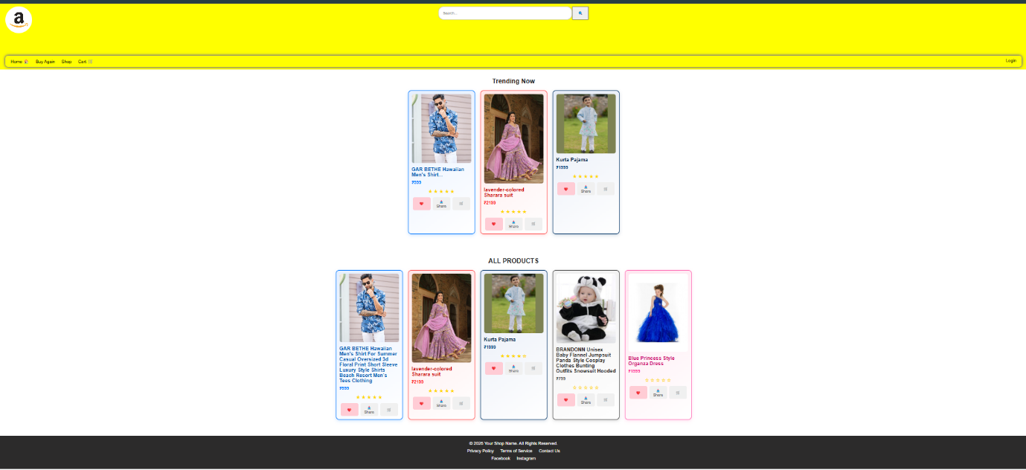

2
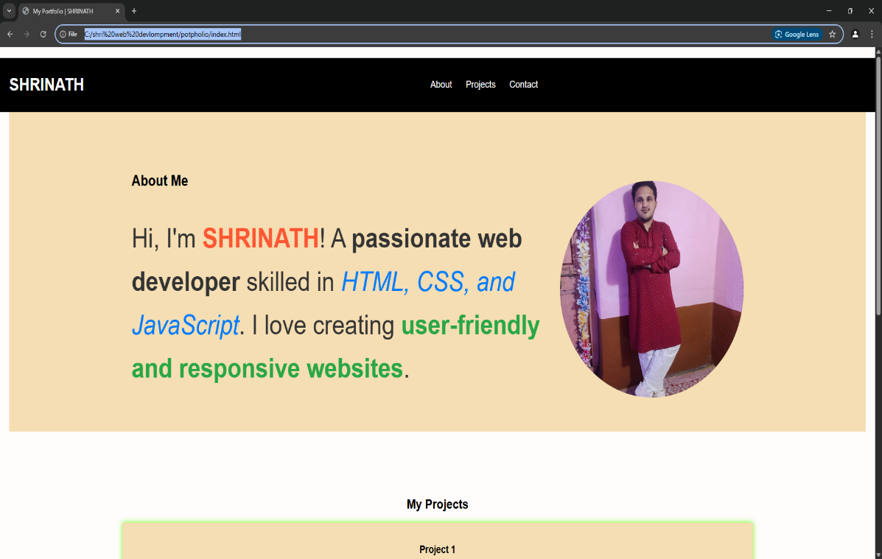

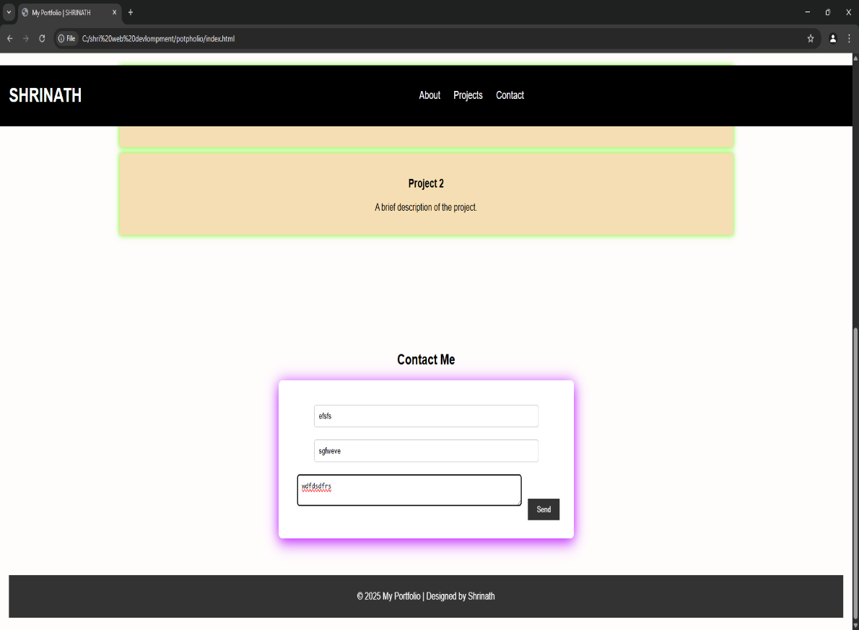
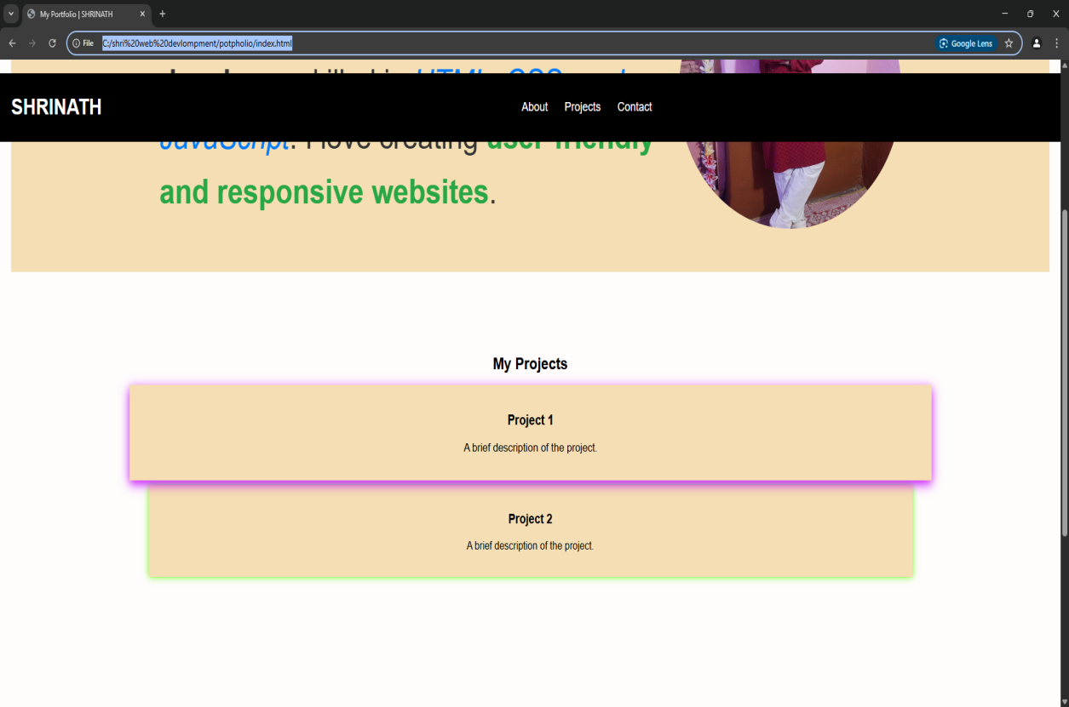

3

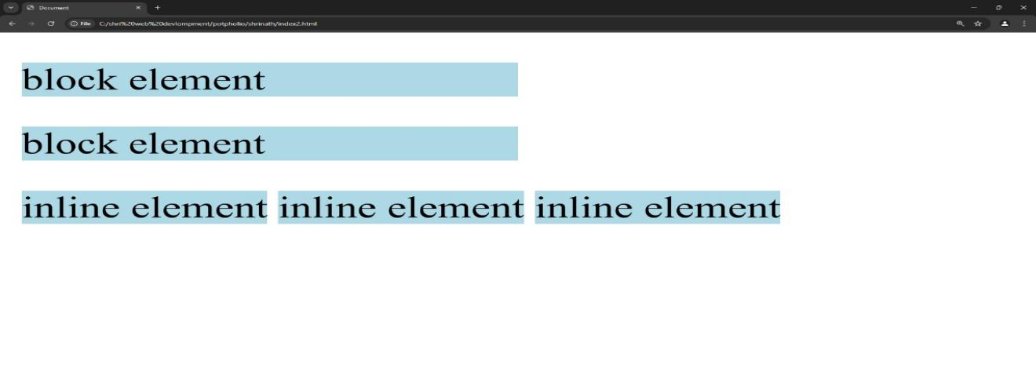

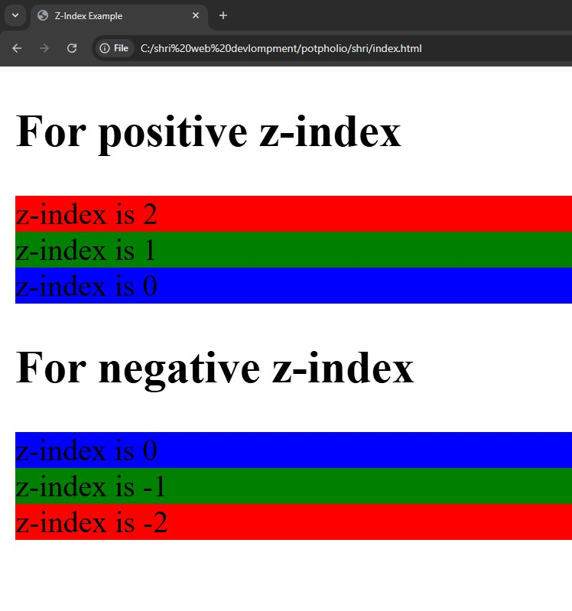
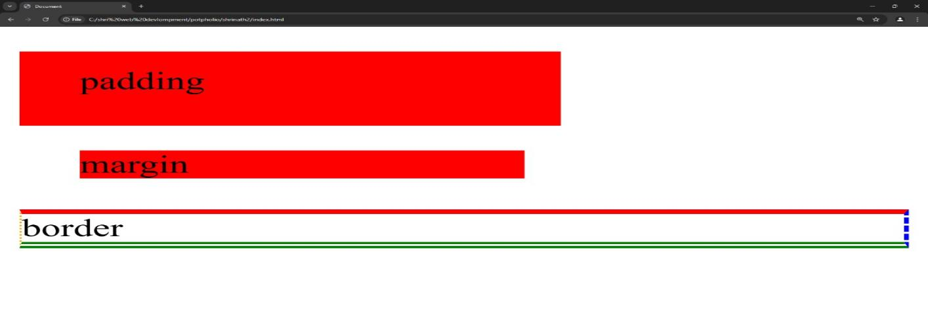

4
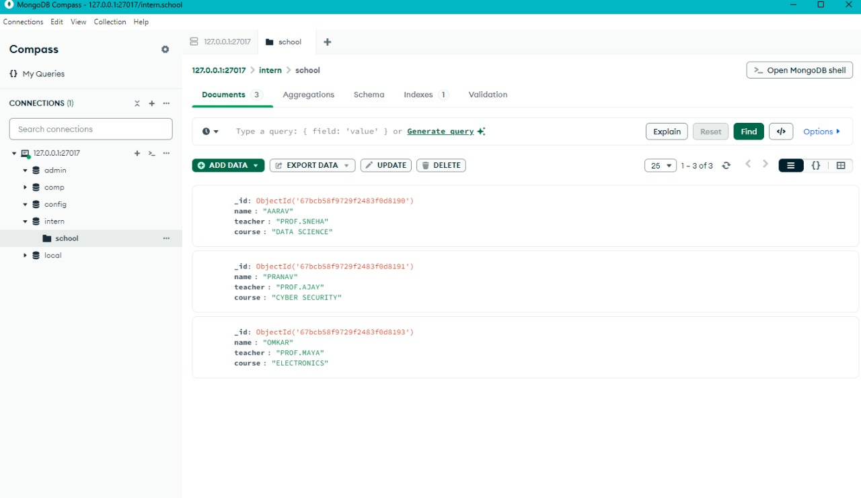

5
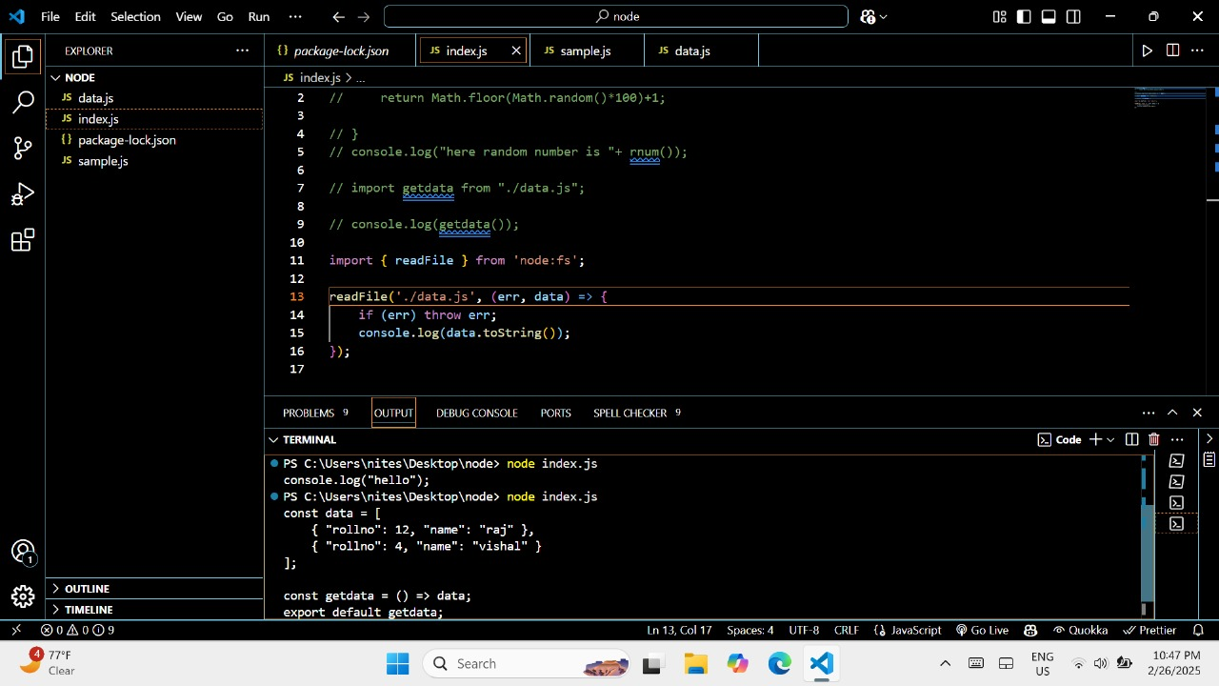

7. Suggestions Recommendations

Suggestions for Future Interns and Students

- Start with a Clear Plan:
Before beginning development, it is essential to plan the project architecture and modules properly. Creating wireframes or mock-ups using tools like Figma or Adobe XD can help visualize the final output and reduce rework.

- Master the Basics First:
A strong foundation in HTML, CSS, and JavaScript is critical. Spend time learning how these technologies work together before diving into frameworks like React.js or backend tools.

- Version Control is a Must:
Use Git and GitHub from day one. It not only tracks changes but also helps in collaboration and code backup. Learning basic Git commands can make project handling much easier.

Recommendations for Improvement

      - Integrate More Real-world Functionality:
Future projects can benefit from integrating user authentication, payment gateways, or real-time data using APIs. This will simulate real-world applications more closely and add more depth to the learning.

      - Use Frameworks and Libraries Wisely:
While learning raw code is essential, incorporating Bootstrap, Tailwind CSS, or React can save time and improve productivity once basics are mastered.

      - Security Should Be a Priority:
Even in student projects, implement basic security measures such as input validation, password hashing, and HTTPS. This instills good development practices early on.

8. Conclusion

The Software Development Internship at DCDIUM Technologies Pvt. Ltd. provided a valuable and enriching experience, allowing me to apply theoretical knowledge in a real-world setting. Over the course of the internship, I worked on several core aspects of web development, which helped strengthen my understanding of both front-end and back-end technologies.

Throughout the internship, I developed and completed various tasks, such as designing a portfolio website, building an e-commerce web interface, and exploring modern development tools and frameworks. Working with HTML, CSS, and JavaScript helped me understand the foundation of user interfaces, while diving into tools like MongoDB and Node.js gave me a taste of back-end development and data handling. The integration of these technologies taught me how web applications function as a whole—from layout design to server-side logic and database connectivity.

This internship was not only about writing code but also about learning problem-solving, debugging, and code optimization. I encountered challenges such as browser compatibility, responsive design issues, and handling asynchronous operations, which pushed me to research and find effective solutions. These challenges enhanced my critical thinking and taught me how to work independently and in a structured manner.

One of the major highlights of the internship was understanding the importance of modular development. Breaking down the project into smaller modules—like user interface, navigation, data management, and file handling—made the workflow more organized and easier to maintain. Additionally, I learned how to use version control tools like GitHub, which helped track changes and collaborate more efficiently.

The experience also gave me insight into the expectations of working in a professional environment, including the importance of deadlines, documentation, and security practices. I became more comfortable using tools such as VS Code, Chrome DevTools, and Live Server, which are essential in modern web development.

In conclusion, this internship has laid a solid foundation for my career as a web developer. It provided practical exposure, improved my technical skills, and helped me understand the software development lifecycle. I feel more confident in building interactive, scalable, and secure web applications. I am grateful to DCDIUM Technologies for providing this opportunity and look forward to continuing my journey in the field of software development with even greater enthusiasm and dedication.

